**DNA structure:**3.2 billion **base pairs**碱基对.The **structure of DNA** is a double helix. **Deoxyribonucleic acid脱氧核糖核苷酸** is found in the nucleus(细胞核), chloroplasts(叶绿体), and mitochondria(线粒体) of eukaryotes(真核生物).**Molecule** that carries the information for the growth, development, functioning and reproduction of all known living organisms (and viruses).**Nucleotides**核苷酸:Thymine胸腺嘧啶-Adenine腺嘌呤 and Guanine鸟嘌呤-Cytosine胞嘧啶**Antiparallel**反平行because one strand runs in the 5′(contains phosphate group 磷酸基团)→3′ (hydroxyl group 羟基)direction and the other runs in the 3′→5′ direction. ·**Polymerase Chain Reaction (PCR) 聚合酶链反应** (amplify a DNA sample)PCR COVID testing relies on 3 set of primers targeting 3 different regions of the SARS-COV-2 genome.**1 PCR Preparation准备阶段 Primers引物**: **1.** primers will bind at a specific DNA sequence and mark the beginning of the DNA amplification. They define the length of the PCR product by limiting the sides of it. **2.** Primers are short fragments of DNA or RNA used to start DNA synthesis by a DNA polymerase. **Nucleotides:** nucleotides are required to build the new DNA sequence; they are the DNA building blocks. **DNA polymerase**: DNA polymerases are enzymes that are responsible for DNA synthesis (assembles the nucleotides based on the template sequence). Taq polymerase (most common DNA polymerase **DNA template:** 1. The basis of new DNA sequence amplification.2. Perform DNA isolation to extract DNA from cells. (First step) **Extra care with contaminations A thermocycler 2 PCR Experiment试验阶段**1. **Denaturation Step** (95 °C): At this high temperature, the hydrogen bonds holding together the two DNA strands are broken, and the DNA strands fall apart. The single-stranded DNA template is now available for copying.2.**Annealing step**(低温退火5-10 °C below the primer with lower Tm):short DNA pieces (primers) bind at complementary sites of the template DNA. The primers define the target sequence, which is the specific region of DNA that will be copied.3. Extension Step (72°C): An enzyme (DNA polymerase) is responsible for copying DNA. It recognizes the 3′ end of a primer bound to a template strand and starts copying the template DNA. It is a thermostable热稳定 polymerase (be active in the high temperature utilized).→DNA synthesis·The steps are repeated many times (often 30), producing billions of DNA copies of specific regions. **Gel electrophoresis凝胶电泳.①**To separate charged macromolecules (DNA, RNA, or proteins) of different sizes and to estimate their length. ②DNA (nucleic acids) is negatively charged, at neutral or basic pH in an aqueous environment, this technique is often used to separate DNA or RNA molecules.③The process is also useful to isolate and extract DNA fragments of a specific size.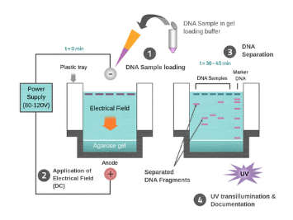 **Gel electrophoresis preparation准备阶段**1.Semi-solid, porous gel matrix. 2.Agarose琼脂糖 or polyacrylamide gel聚丙烯酰胺凝胶. 3. DNA or RNA sample 4. Loading buffer: To help visualize how far the DNA or RNA has traveled during gel electrophoresis. 5.Dye.(Fluorescent or colored dyes) 6. Molecular weight standard samples or "ladders" **Gel electrophoresis procedure程序阶段:** Smaller DNA molecules move faster through the gel than larger DNA molecules, leading to size separation. This difference in the rate of migration separates the fragments on the basis of size. **Gel electrophoresis analysis:** the different fragments are visualized as bands at specific distances from the top of the gel (the negative electrode end) on the basis of their size. The sizes of the nucleic acid samples can be estimated by comparing the distance with the molecular weight standard samples (also called DNA ladder).**DNA ladder**1. A mix of DNA or RNA fragments with known lengths. 2.Contains DNA of different lengths. The size of the fragments is determined by running a gel with the ladder in a well next to the samples with unknown lengths. **Sequencing by Synthesis**1. DNA is sheared into 200bp pieces 2. The sheared DNA is attached to the surface of a flow cell 3. The attached DNA is amplified via PCR

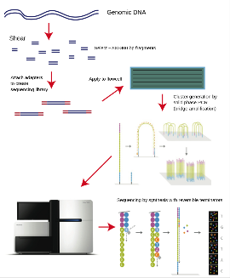4. Sequencing by synthesis using fluorescently labelled nucleotides **Illumina:** the reversible dye termination technology

**Next Generation Sequencing** Massively Parallel. /Higher throughput. /Lower cost. /Faster. /More accurate. /Although, Shorter read lengths1.Sample preparation:1) Fragmented (limit: length of DNA sample; max:250bp)-1. Sonication 2. Enzymatic 2) end-repair-To prevent DNA with these sticky ends from pairing with another DNA(Sticky ends to Blunt ends) 3) A-tailing (3’-A) A-overhang adapter ligation (function of adapter: primer and flow cell docker) 5) PCR amplification 2. Cluster generation: Bridge PCR and Flush 3. Sequencing process- by synthesizing each base pair.( Polymerase attachment\ Nucleotides tagged with fluorophore\ Fluorophore Detection\ Cleavage and removal)

**Third Generation Sequencing –** longer reads/ portable / speed 1. **Nanopore Sequencing** (Oxford Nanopores)【DNA or RNA move through the nanopores, disruption in the current.determine the sequence of bases in the strands of DNA or RNA passing through the pore.】/ 2. SMRT sequencing (Pacific Biosciences)

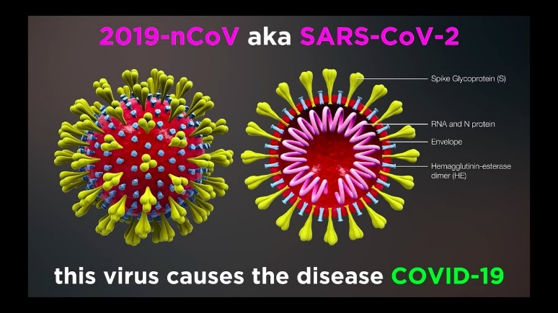**Detect proteins**： (The spike protein is a protein. /Antibodies are protein)→

**①ELISA** (enzyme-linked immunosorbent assay酶联免疫吸附测定) (high speed sensitivity and strong specificity)

·Uses antibodies抗体 and enzyme-mediated酶介导 color changes to detect the presence of either antigens抗原 (proteins蛋白质, peptides肽, hormones激素) or antibodies抗体(antibody-antigen reactions)

**Basic steps** of ELISA:1. Coating/capture: Immobilization固定 of the antibody or antigen to the surface of the microplate wells 2. Blocking: Addition of irrelevant protein or other molecules to cover all unsaturated不饱和 surface-binding sites of the microplate wells 3. Probing/detection: Incubation with the labeled antigen or antibody 4. Signal measurement: Detection of the signal generated via the labeled antigen or antibody

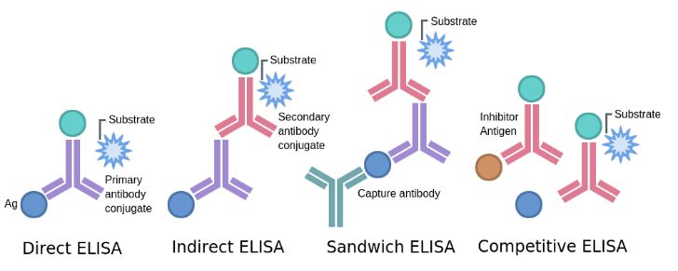**Types of ELISA： -Direct ELISA：**response to an antigen.**-Indirect ELISA:** antibody concentration**-Sandwich ELISA** Analyzing complex samples.**-Competitive ELISA:** Detecting small antigens that cannot be bound by two different antibodies.

**ELISA elements:** Plate/shaker/wash/stop solution/tetramethylbenzidine/control.

**ELISA troubleshooting:** High background/Low OD reading/Poor standard curve/No signa

descriptdescript**②Lateral flow assay**(No need for specialized equipment and answer in 30 minutes)l

**③Biosensor**

**④Proton-ELISA:** develop/take advantage of biochemical reactions that release H+ (proton) so you can use a ISFET readout

**⑤Electrochemical Sensors** | **Nernst Equation**

Glucose + Gox-FAD → Gluconolactone + Gox-FADH2 | Gox-FADH2 + O2 → Gox-FAD + H2O2 | H2O2 →2H+ + O2 + 2e-

**Hemophilia:** VIII (FVIII) and factor IX (FIX). (Factor IX is a blood clotting factor-activated by vitamin K.)||1M (one molar) = 1mol/L= 6.022 1023 L-1

**Macrophage巨噬细胞** phagocytosis吞噬作用 | antigen presentation | induction of inflammation诱发炎症

Lymphatic System:Bone marrow / Lymph nodes and vessels / Spleen / Thymus / Tonsils / Peyer's patches

An electronic glucose meter relies on oxygen in blood to provide an accurate measurement of glucose**False: use a method called enzymatic electrochem8ical detection to measure (酶电化学检测)**What would happen you do not add the primers in a PCR reaction?**不加引物p都得不到 No PCR reaction would take place** 3 billion COVID-19 tests performed through to mid-2022 and half of them were conducted in low-income regions thanks to the wide adoption of lateral flow devices.**不是一半，只有0.4%Incorrect. Only 0.4% of the 3 billion COVID-19 tests performed through to mid-2022 were conducted in low- income regions**DNA is composed of four different genes that carry the instruction for making protein molecules.**DNA由4种核苷酸构成不是基因Incorrect. DNA is composed of four different nucleotides that are known by their initials A,C,G,T**Which DNA sequencing technology would you employ to perform a DNA sequencing experiment on Mars?**只有nanopore是可携带的Nanopore sequencing as it is the only portable DNA sequencing technology**Nanopore sequencing relies on fluorescent labelled nucleotide to control the speed of the motor protein**Incorrect. nanopore sequencing does not require fluorescently labelled nucleotides**ISFET DNA sequencing relies on the measurement of the current flowing at the gate electrode to determine the correct DNA sequence**Incorrect. lSFET relies on the drain current which depends on the concentration of protons in solution**How can you successfully perform an electro chemical measurement using only a 2 electrode setup?**You can either perform a potentiometric measurement or use a micro-electrode to minimize the current flowing in the circuit**In a typical electrochemical experiment, the working electrode is the sensor and it is usually composed of conductive materials**Correct. Carbon, gold or platinum are generally used as electrode materials**Continuous glucose monitoring (CGM) devices are now a fully approved medical device because the sensor is implanted within a blood vessel.Incorrect. CGM measure the glucose concentration within the interstitial fluid不需要植入血管

**Unit1.1** **An integrated semiconductor device enabling non-optical genome sequencing:** 利用集成电路中的离子敏感器ion-sensitive sensors 直接感知DNA聚合酶polymerase合成synthesis产生的离子，从而获取DNA序列信息。原理：通过使用集成芯片测序，感知DNA聚合中释放的氢离子变化确定DNA核苷酸顺序。特点：1. 利用半导体技术实现低成本\大规模生产 2. 高准确性和稳健性，适用于细菌基因组测序和全基因组测序3. 对短序列细菌基因组准确性高4. 能够识别SNP，实现高质量的全基因组测序结果 **Piet Bergveld - 40 years of ISFET technology:** 介绍了ISFET（**Ion-Sensitive Field Effect Transistor**）的发明过程。**特点**：①勿需用到脆弱的玻璃膜电极，避免发生电极损伤的问题。②体积小，重量轻，便携③响应速度快**.优点**：①抗冲击性强：因为无需脆弱的玻璃膜电极②响应时间短：相较玻璃膜电极③微型化的可能：体积小巧 **缺点**：①长期稳定性欠佳②生产成本高③对环境有要求：有机溶剂对ISFET有一定的腐蚀性**应用场景：①**油漆工业的传感器②监控ph值③人工心脏起搏器项目④用于测量血液的PH值的导管系统**Automated forward and reverse ratcheting of DNA in a nanopore at 5-Å precision：**主要介绍了一个新的DNA测序技术。**DNA**通过纳米孔控制前进和后退，平均每秒可以处理2.5-40个核苷酸。**纳米孔策略需要整合六个功能：**1. 自动捕获和处理基因组DNA模板2. 系统的空间控制3. 时间控制4. 避免使用复杂活性电压控制的策略 5. 能确定单个碱基的传感器6. 能够识别同源聚合体区域中核苷酸之间转换的计数器**减慢DNA模板移动速度的方式：①**通过配对纳米孔和酶引擎来降低速度的策略，②论文中通过DNA聚合酶phi29 DNAP的控制功能来降低DNA在纳米孔中的运动速度，可通过单个纳米孔按照顺序处理多大500个DNA分子**可能发生的错误：**1. 链位移速度超过数据获取速度导致2. 链反复滑动使得给定位置被读取多次**概率：**插入错误率：5-10.5%删除错误率：5-15%综合错误率：10-24.5%**Three decades of nanopore sequencing：**介绍了纳米孔测序。依赖于通过DNA分子的单独核苷酸移动速度来探测DNA序列。DNA分子通过电厂驱动过纳米孔，所以需要精确读取每个核苷酸**DNA分子移动过程涉及的两个关键因素：**1. DNA和纳米孔之间的作用力

电场力来调控2. 纳米孔的几何形状，使用生物工程或物理方法进行优化设计 **突破点：**串行化方法控制DNA移动过程，利用特殊的酶将DNA序列进行串行化，通过纳米孔进行单个核苷酸测序**特点①**大大提高测序速度和精确性②需要解决酶活性和稳定性问题③可以通过其对a-溶血素离子电导的特征来区分由所有胞嘧啶构成的聚-d（C）链中的一种腺苷核苷酸**MinION设备优点**1. 便携2. 实时数据分析3. 长读长获取更加全面的基因信息4. 无需特殊设施连USB**缺点**1. 错误率高5-15%2. 需要高性能电脑3. 实时性导致的问题设备随着测序的进行表现会下降 **Unit1.2论文:Electrochemical ELISA-based platform for bladder cancer protein biomarker**

**detection in urine：目的：**发展廉价、准确且可靠的膀胱特异性癌症生物标志物检测诊断设备**主要目标**：NUMA1和CFHR1**介绍了**一种新型的基于电化学的ELISA的诊断平台**开发出**了一种全自动流体原型：可以实现过程的自动化和检测的多路复用。**验证了**非现场PC矩阵传感器的性能：anti-CFHR1/FNAB/PC/玻璃电极可以用于在PBSTSB和尿液中在1 ng/ml - 10 ng/ml的范围内对CFHR1进行传感。**设计了**一个微流控系统的原型设备:通过配合使用特定的抗体和蛋白酶标记的检测抗体使得检测信号被转换成电化学活性形式.**使用范围：**可以用于检测1ng/ml - 100 ng/ml 范围内的NUMA1**Proton-ELISA: Electrochemical immunoassay on a dual-gated ISFET array设计了**一种名为质子ELISA(H-ELISA)的电化学免疫测定设备它利用由酶葡萄糖氧化酶产生的质子作为免疫测定的检测媒介。**DG-ISFET组成部分 ：**由128*128阵列的16384个感测晶体管组成，每个晶体管都有可分别寻址的背门，可以检测C反应蛋白和免疫球蛋白E的低浓度甚至到12.5和125pg/ml **ISFET,DG-ISFET和H-ELISA的比较 ：DG-ISFET：①**独特的双门设计显著增强信号②短时间内对16384晶体管进行扫描③提高信号通量和精确性④适合快速大规模的离子活动检测**H-ELISA**：①利用质子作为免疫测定的检测介质②通过Dual-Gate ISFET设备进行检测③使用ELISA夹心模式1.一个抗原需要两种不同的抗体结合才能产生阳性型号2.

更低的假阳性发生率3.更高的保真度和特异性③GOx-FeSO4信号放大系统使得检测灵敏度得到大幅度提高④适合高灵敏度和特异性的应用**优点**1. 高灵敏度，质子反应过程能够通过DG-ISFET实时做到灵敏检测2. 适用于复杂生物样品，开展断点H-ELISA实验可以抵消表面污染的影响**缺点①**信号漂移传感器表面污染会导致信号漂移②稳定性较差，影响测量结果准确性